**Assignment- 9**

**Name – Atharva Shivaji Jadhav Roll Number - DXC262AB12035**

**Batch – Dxc-262-Analytics-B12-Azure Company – DXC Technology**

**Employee Domain –Azure Analytics Training Under – Manipal Pro Learn**

1. Explain the steps with screenshots how to create Azure Synapse analytics?

Ans) To create azure synapse analytics we have to follow the following steps

Step- 1: login to the azure portal and search for Azure Synapse analytics

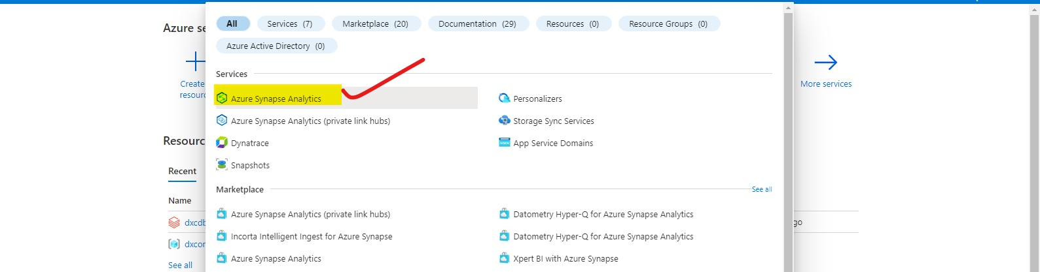

Step- 2 : click on azure synapse analytics and click on create button

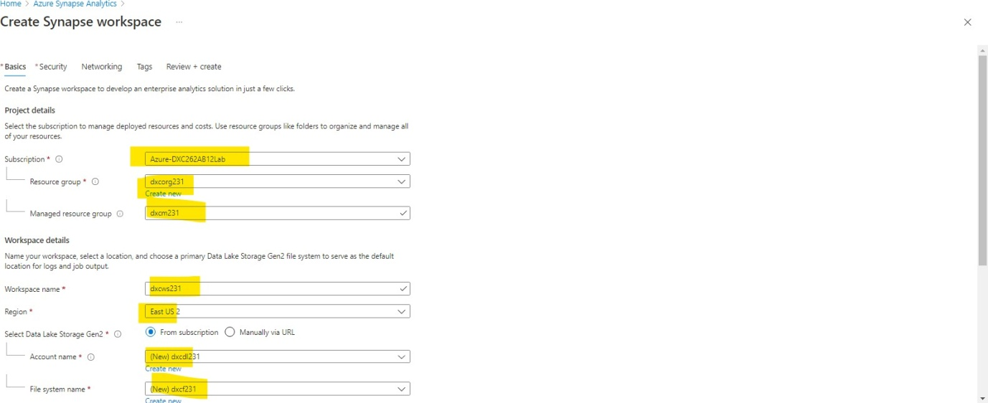

Step- 3: next setup your sql administer and setup your passcode

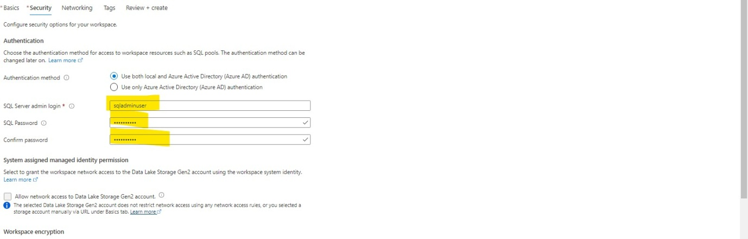

Step- 4: after the validation is done click on create

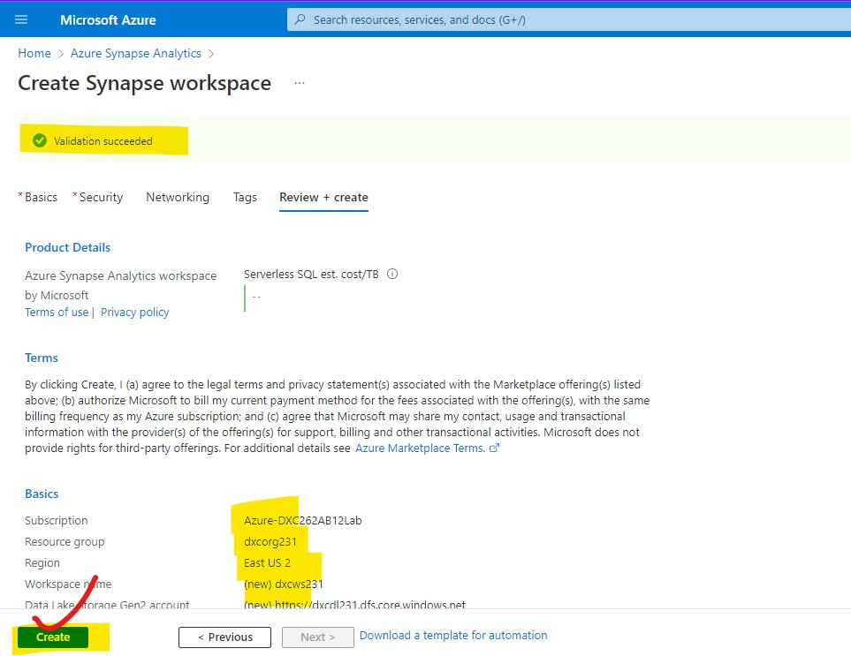

Step- 5: The deployment is going on after deployment click on go to resource button

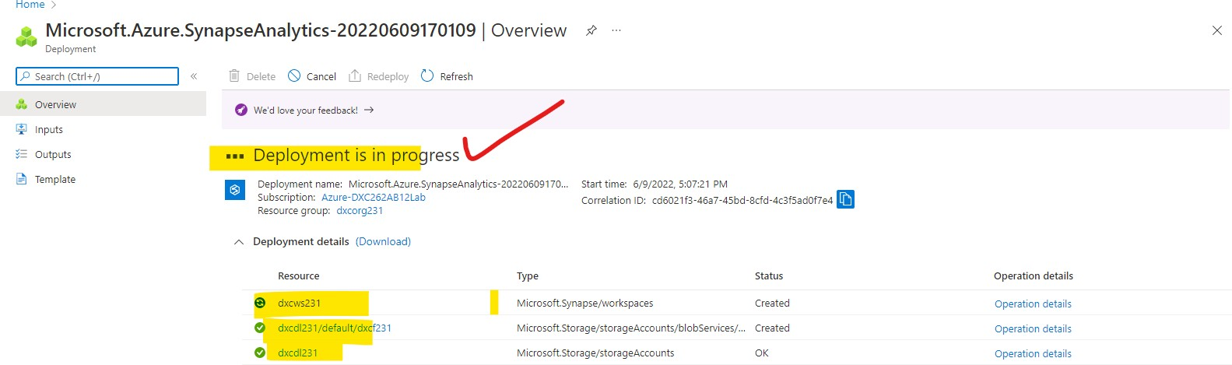

Step- 6: the deployment is completed and click on go to resources

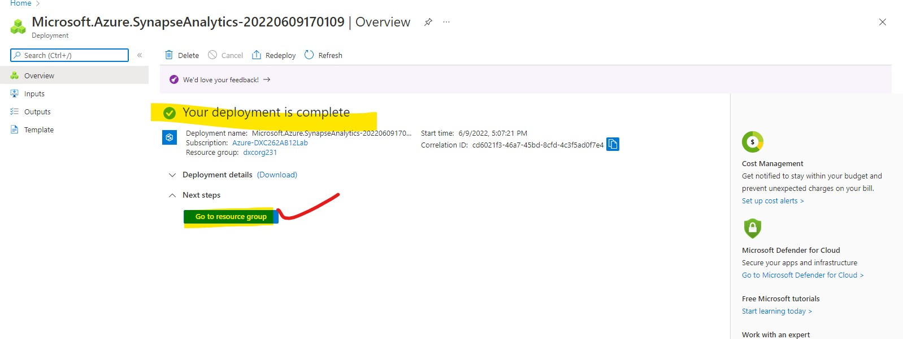

Step- 7: after navigating to that click on synapse studio i t will open in new tab

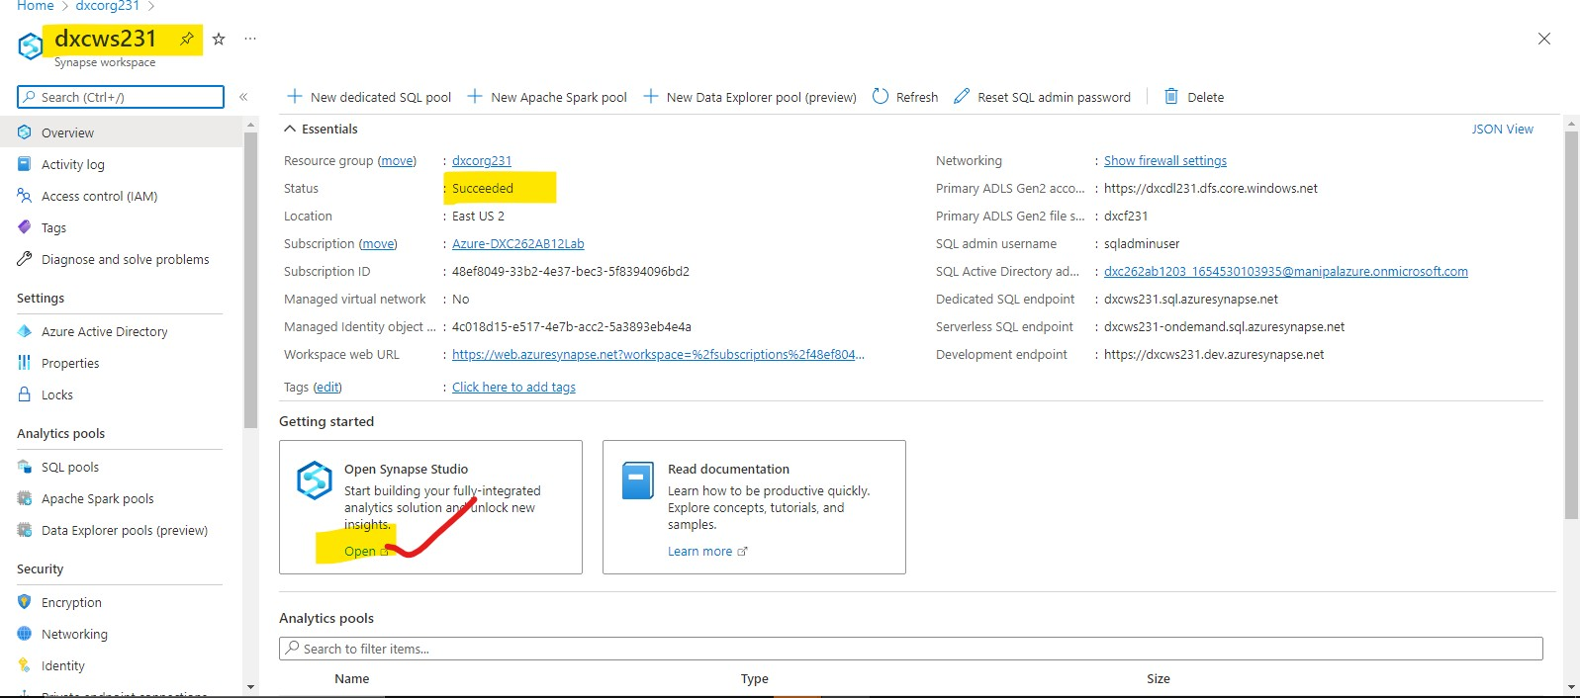

Step- 8: you will navigate to this page, thus azure synapse analytics creation Is done

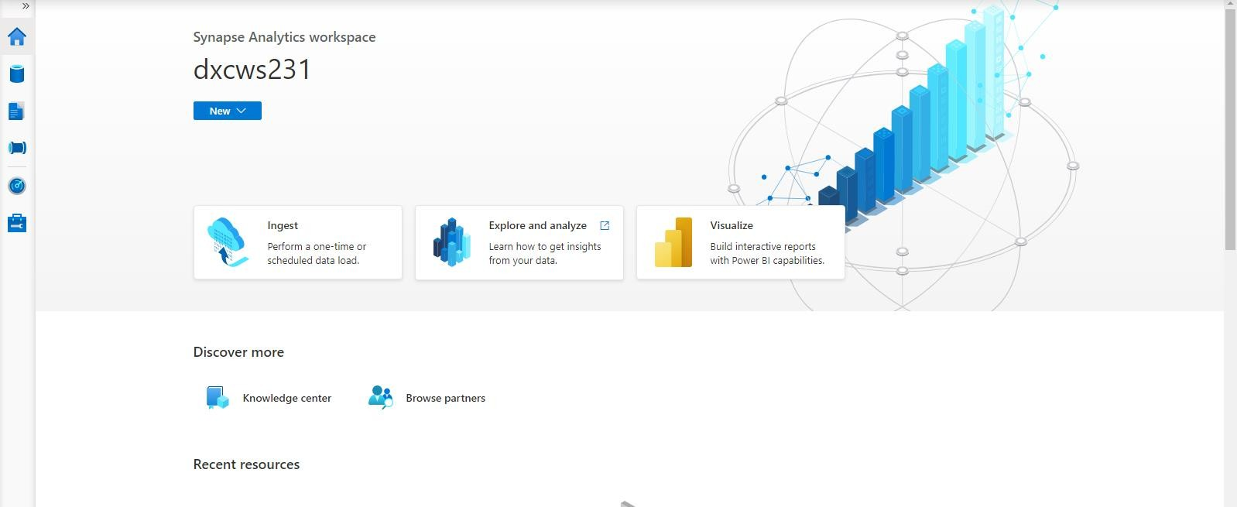

1. Explain the steps with screenshots how to SQL Pool in AzureSynapse analytics?

Ans) in Azure synapse analytics the Sql pool can be created in the below mentioned way Step-1: after opening the home page navigate to manage and choose sql pool

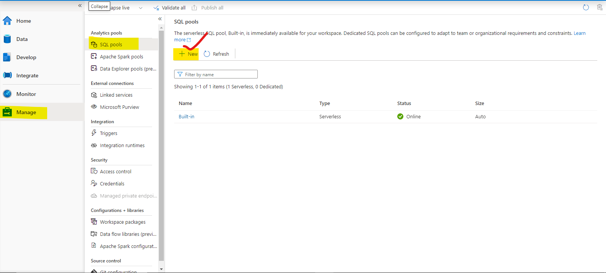

Step-2: after clicking on the new we need to finish the all details review and create

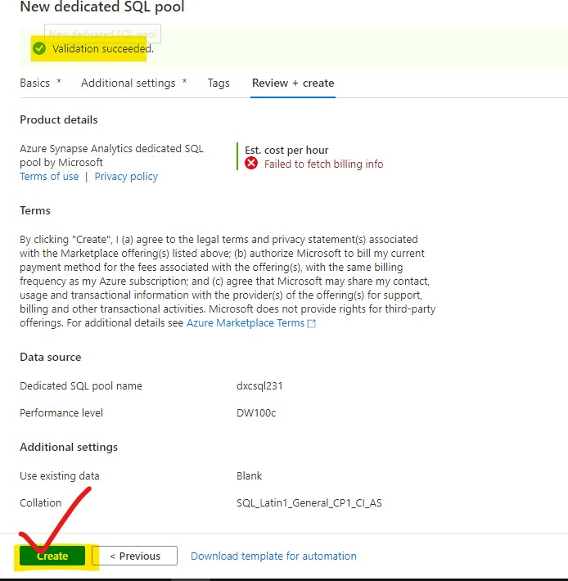

Step 5: the pool sql creation is done

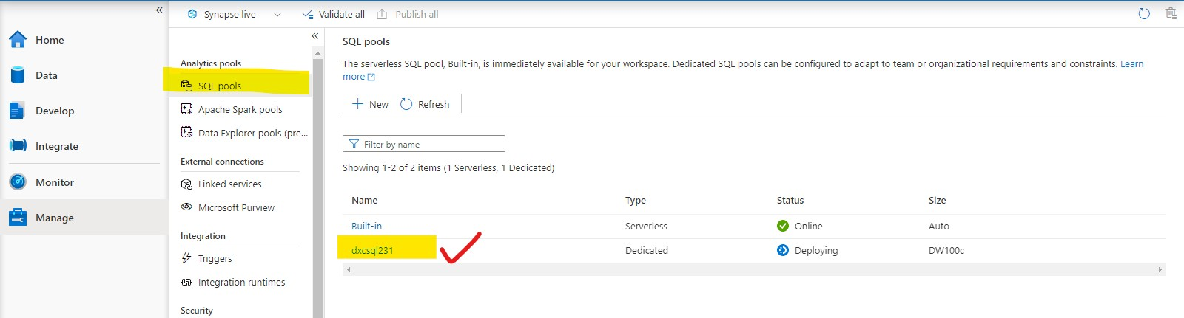

1. Explain the steps with screenshots how to import COVID19 dataset in AzureSynapse analytics and run sample 500 rows & display the output?

Ans) To insert the data in azure synapse analytics we have to follow the below mentioned steps

Step-1: navigate to the home page and click on data

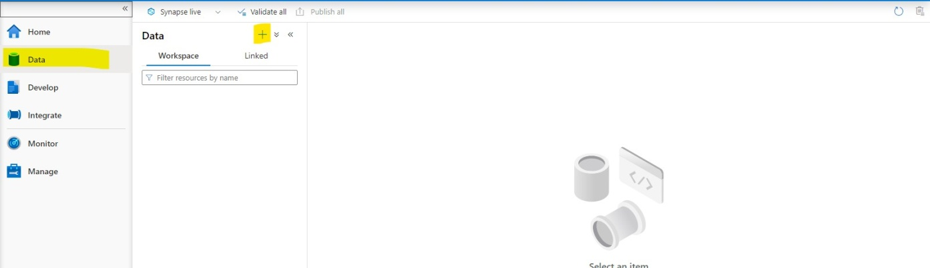

Step-2: click on the + button and choose browse gallery

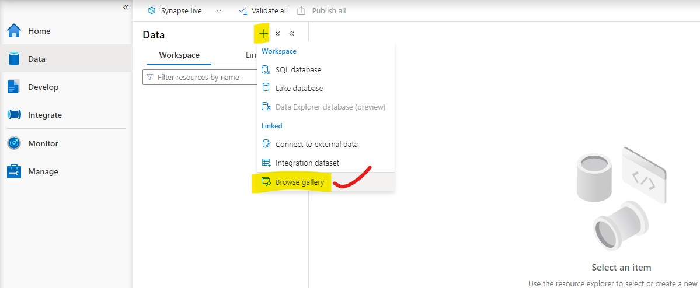

Step-3: select the covid 19 data from the menu from the data sets and add to the data sets after previewing the data

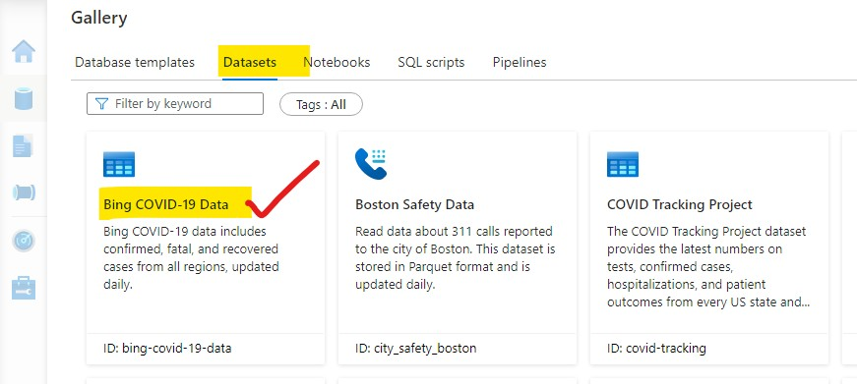

Step-4: after that we will have to following steps

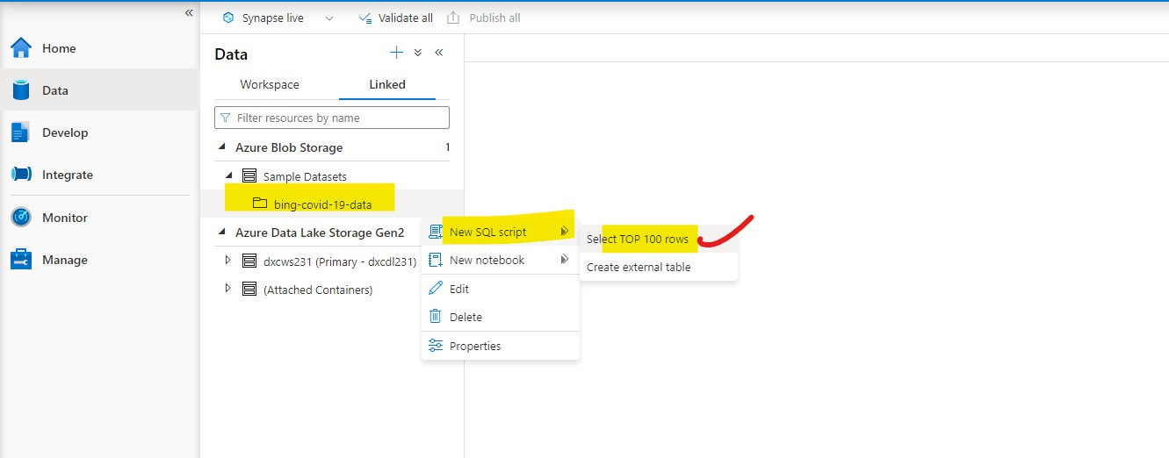

Step-5: after that run the command and the output data will be displayed.

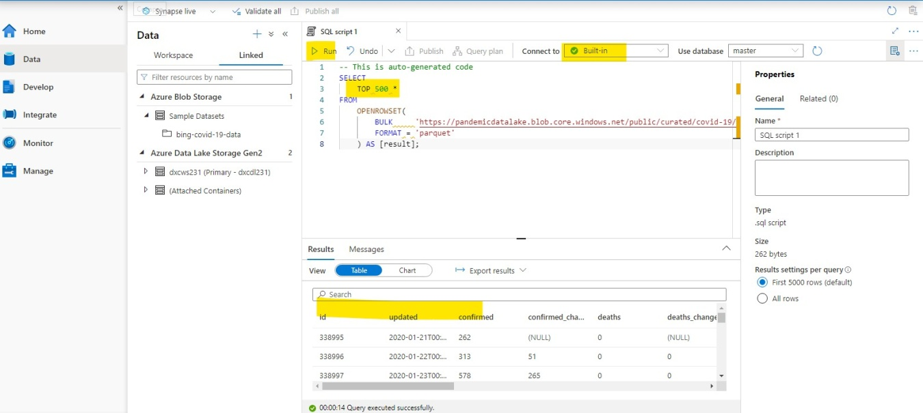

1. Explain the steps with screenshots how to input Boston Safety datasets into AzureSynapse analytics? using Notebooks?

Ans) In order to input Boston safety datasets into azure synapse analytics we have to follow the mentioned steps

Step-1: select the Boston safety data sets from the data sets and click on continue

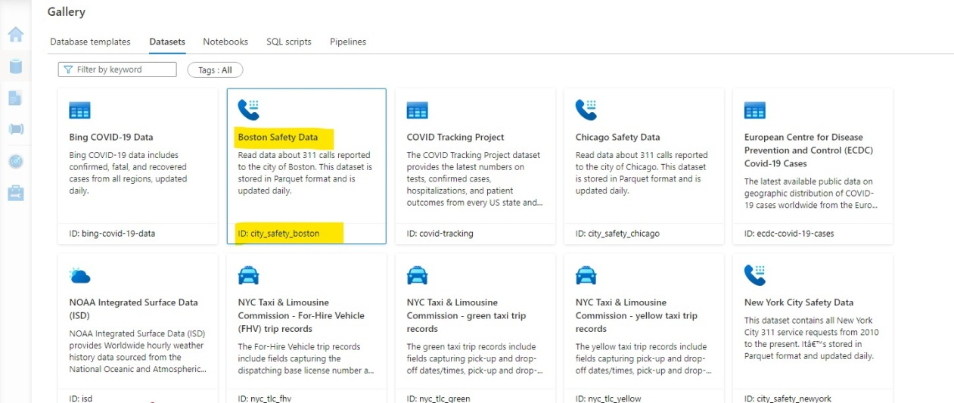

Step-2: After getting data follow the steps refer attachment select the apache pool and Click on run i t takes some t ime to intiate first run.

Step-3: after that the data will be displayed like this.

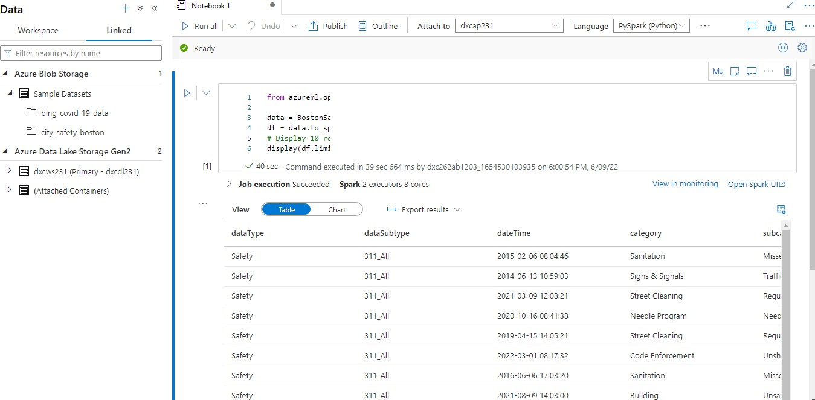

1. Explain the steps with screenshots how to create Spark pool in AzureSynapse analytics?

Ans) To create a spark pool we have to follow the steps mentioned below Step-1: click on manage pools

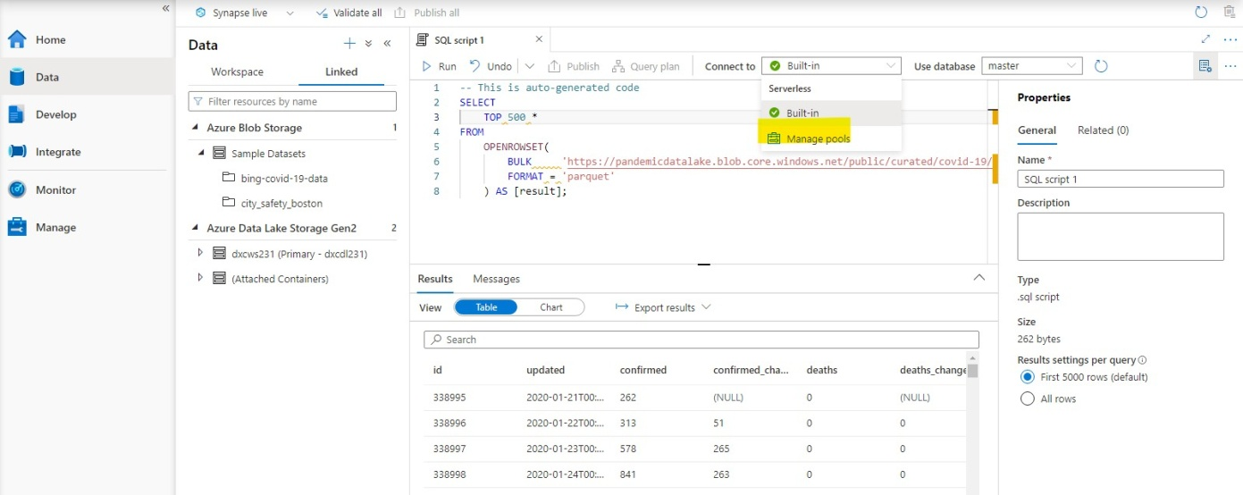

Step-2: after that it navigates to the mange page and select spark pool there refer screenshot

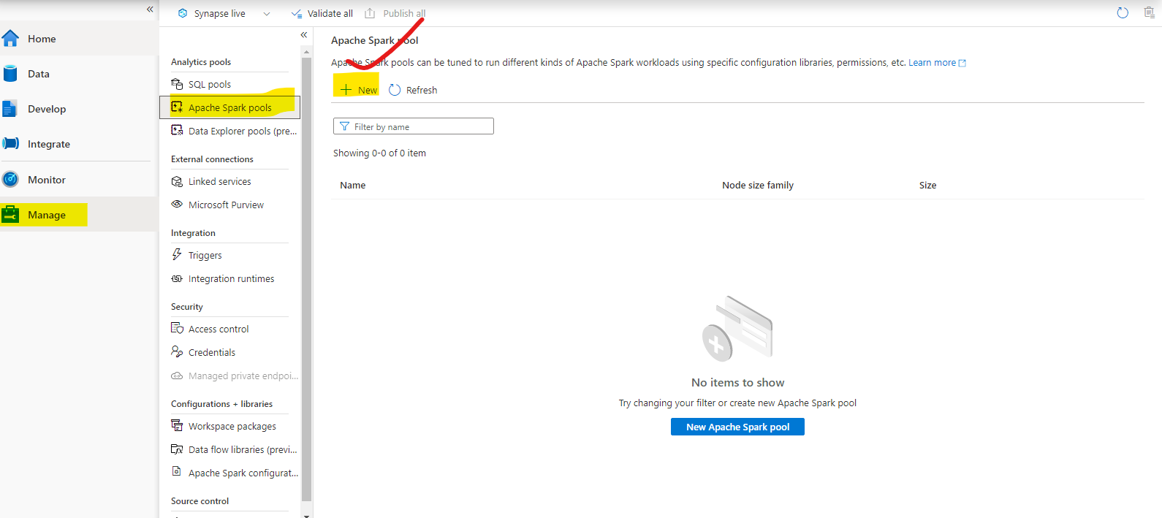

Step-3: fill all the requirements and click on review and create

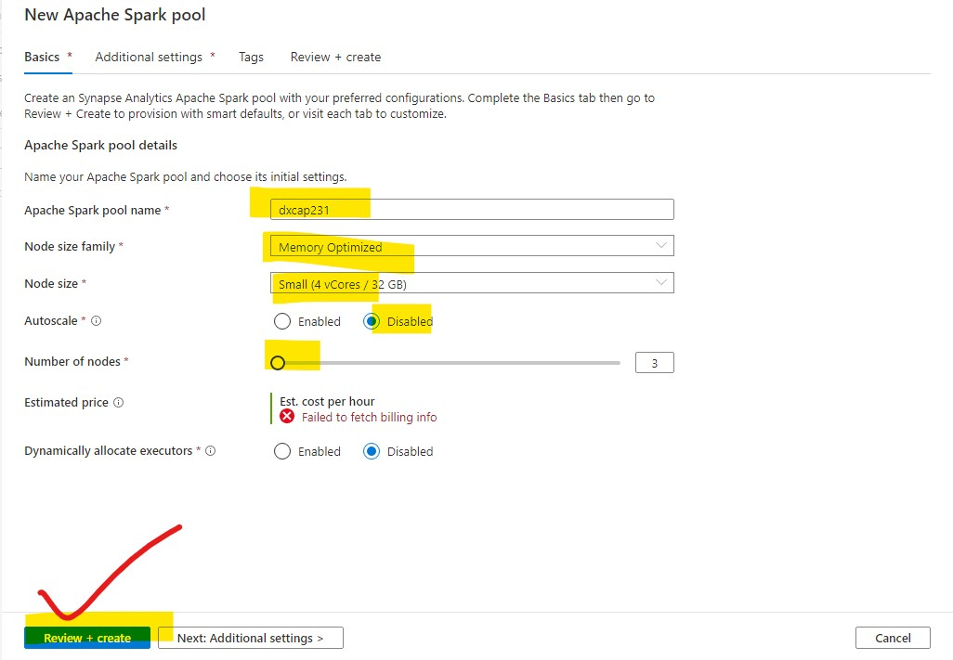

Step-4 : it takes few minutes to deploy

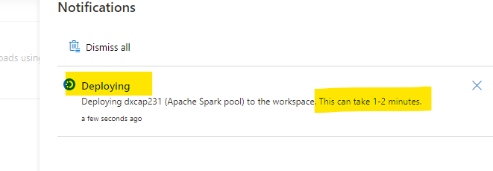

Step-5: and done

1. Explain the steps with screenshots how to create pipeline in AzureSynapse analytics?

Ans) In azure synapse analytics we have to follow to these steps to create a pipe line Step-1: click on integrate,”+” icon and after that click on pipe line

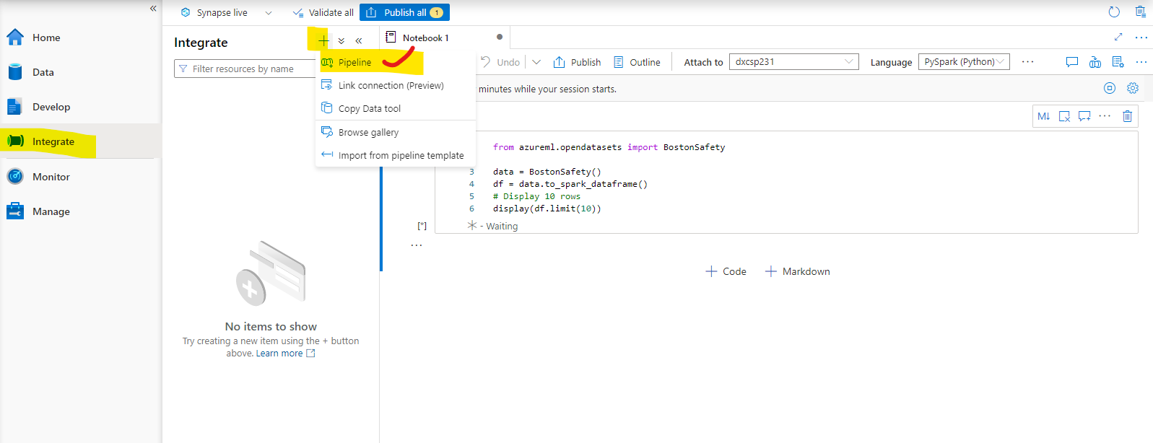

Step-2: The pipe line has created successfully and triggered

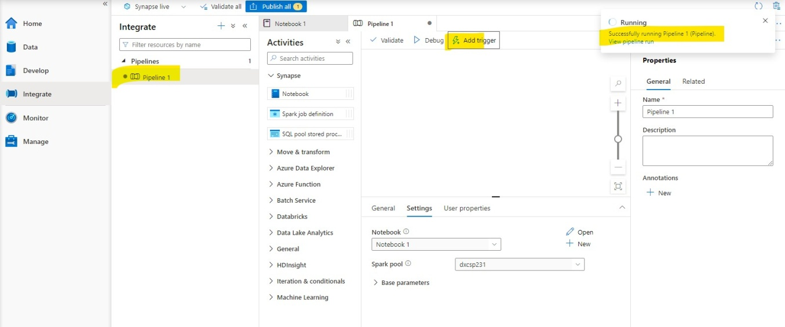

1. Explain the steps with screenshots how to automate the pipelines in AzureSynapse analytics?

Ans) Automation of pipelines is noting but scheduling the pipelines to trigger at time interval given

Step-1: schedule the triggering time and click on ok

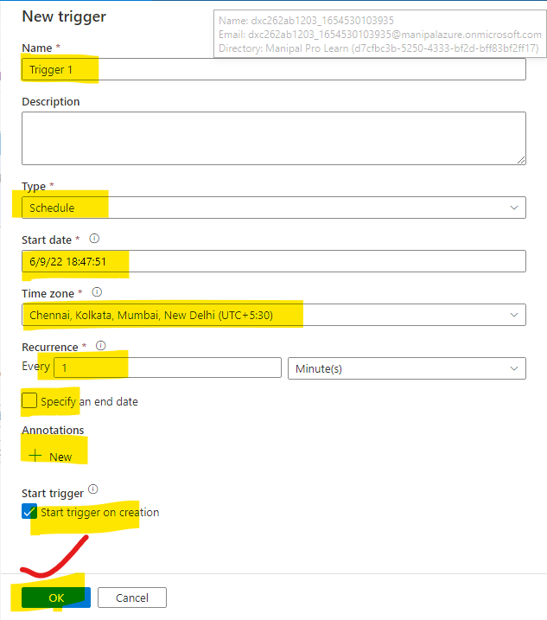

Step-2 : The pipeline will Automatically triggers as per the limit that you have set

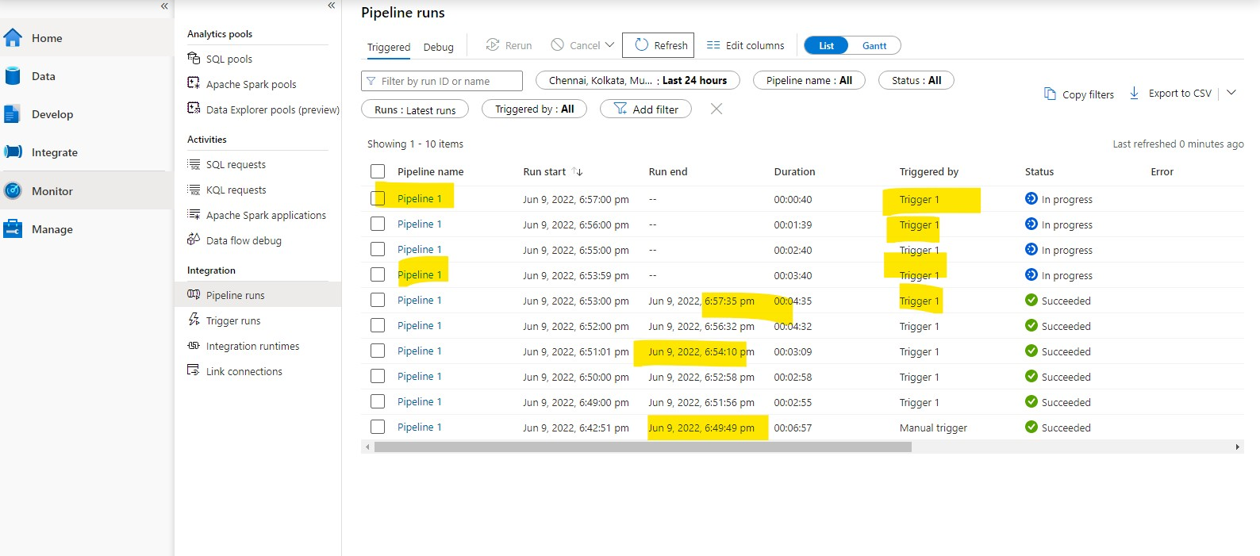

Pipeline runs

Triggered Debug @. Ee“rir ' Carve EE Edit columns



Refresh

Chennai. Kolkata, Mu... : Last Z4 hours



:



Add filter

Status : All



 MslrMreshed 0 minulesago

 Run start 1

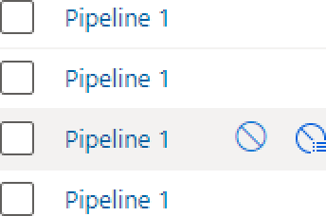Jun 9, 2022, 6:57:00 pm

Jun 9, 2022, 6:56:00 pm

Jun 9, 2022, 6:55:00 pm

Jun 9, 6:53:59 pm

Run end



00:00:40

00:01:39

00:02:40

00:03:40

Triggered by

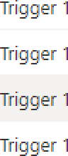

StatMs

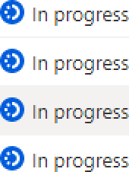

Error

 Jun 9, 2022, 6:53:00 pm

 Jun 9, 2022, 6:52:00 pm

 Jun 9, 2022, 6:51:01 pm

 Jun 9, 2022, 6:50:00 pm

 Jun 9, 2022, 6:49:00 pm

 un9,2022,6:42:51 pm

Jun 9, 2022, 6:57:35 pm 00:04:35

Jun 9, 2022, 6:56:32 pm 00:04:32

Jun 9, 2022, 6:54:10 pm 00:03:09

Jun 9, 2022, 6:52:58 pm 00:02:58

Jun 9, 2022, 6:51:56 pm 00:02:55

Jun 9, 2022, 6:49:49 pm 00:06:57





Manual

@ Succeeded @ Succeeded @ Succeeded @ Succeeded @ Succeeded @ Succeeded

1. Explain the steps with screenshots how create to Databricks?

Ans) to create data bricks we have to follow the following steps Step-1: login into the azure portal and search for the DATA Bricks

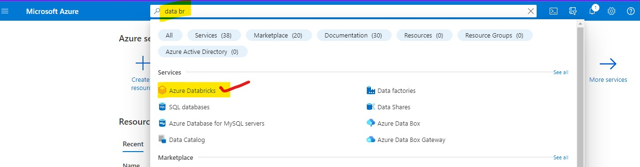

Step-2: click on azure data bricks and it will navigate you to the page. And click on create-to-create data bricks

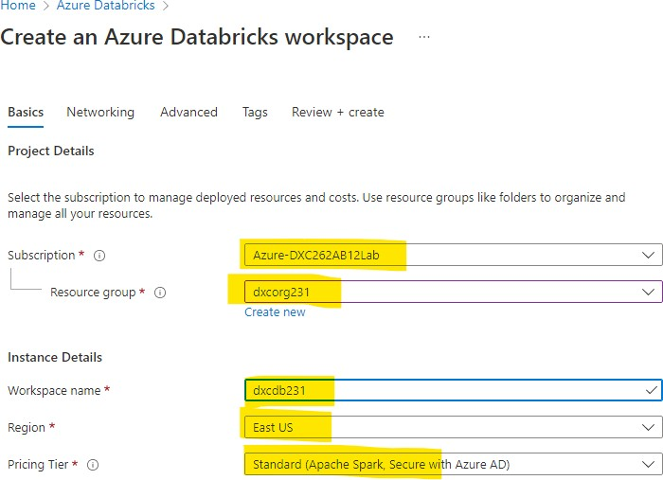

Step-3: after checking all these reviews and create and wait for deployment after deployment we will get like this

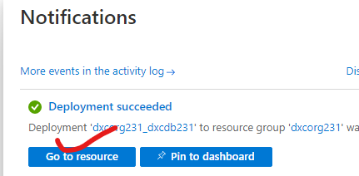

Step-4: after clicking of go to resource button you are navigated to the data bricks

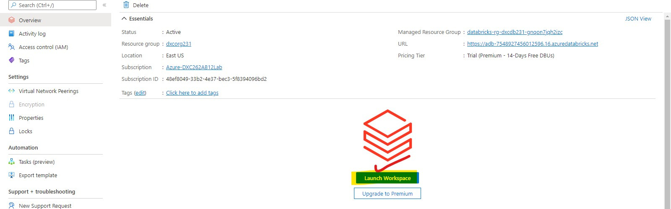

Step-5: after click on launch workspace, you are in data bricks

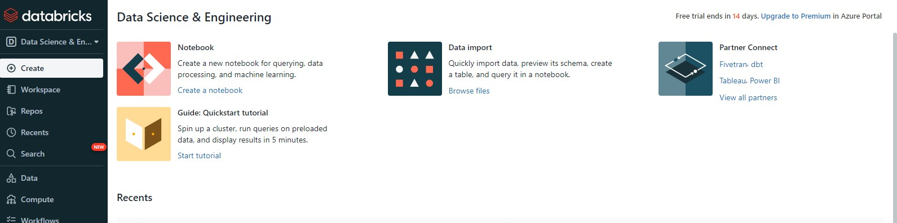

1. Explain the steps with screenshots how to create notebooks in Databricks?

Ans) To create Notebooks in Data bricks we have to follow the below mentioned steps

Step-1 : open azure portal and navigate to azure data bricks after that follow the attached screen shots

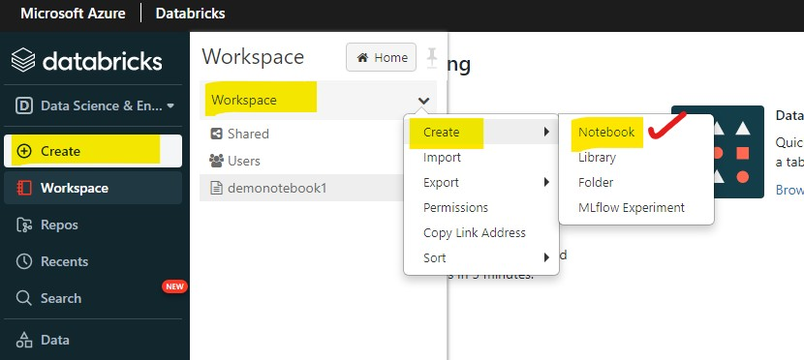

Step-2: click on note book and name it and choose the language , cluster

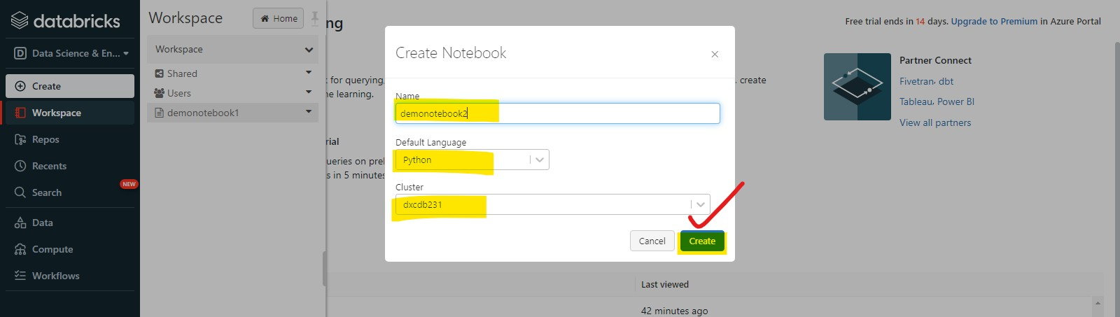

Step-3: The notebook is created in data bricks

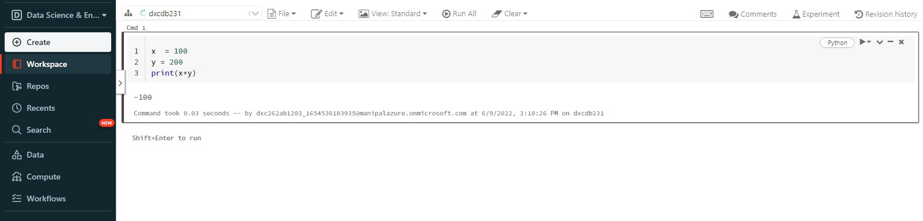

1. Explain the steps with screenshots how to insert data into databricks notebook & display the result?

Ans) in order to insert data into databricks note book we can insert data as mentioned below

Step-1: open the data bricks work space and click on data and it will navigates to a tab and click on create table

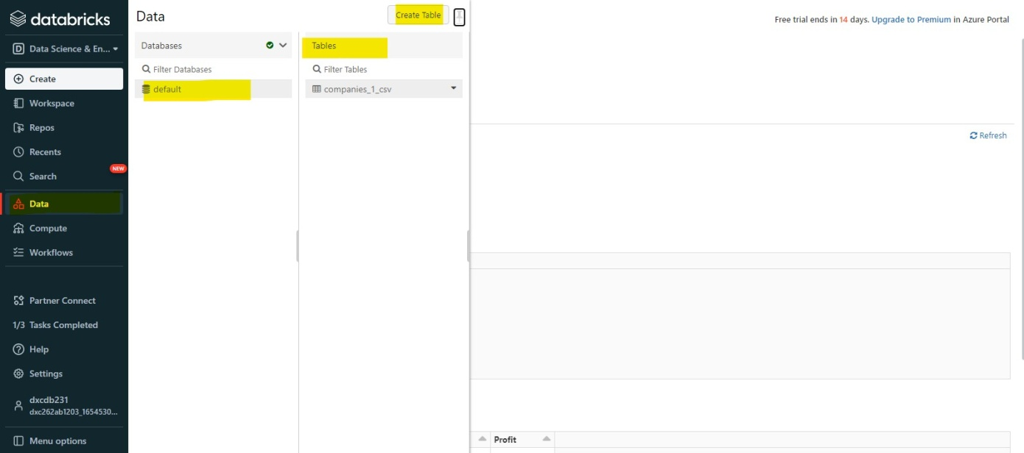

Step-2 : after clicking on create table. We can drag and drop the files which we need to insert int the note book refer attachment for better understanding.

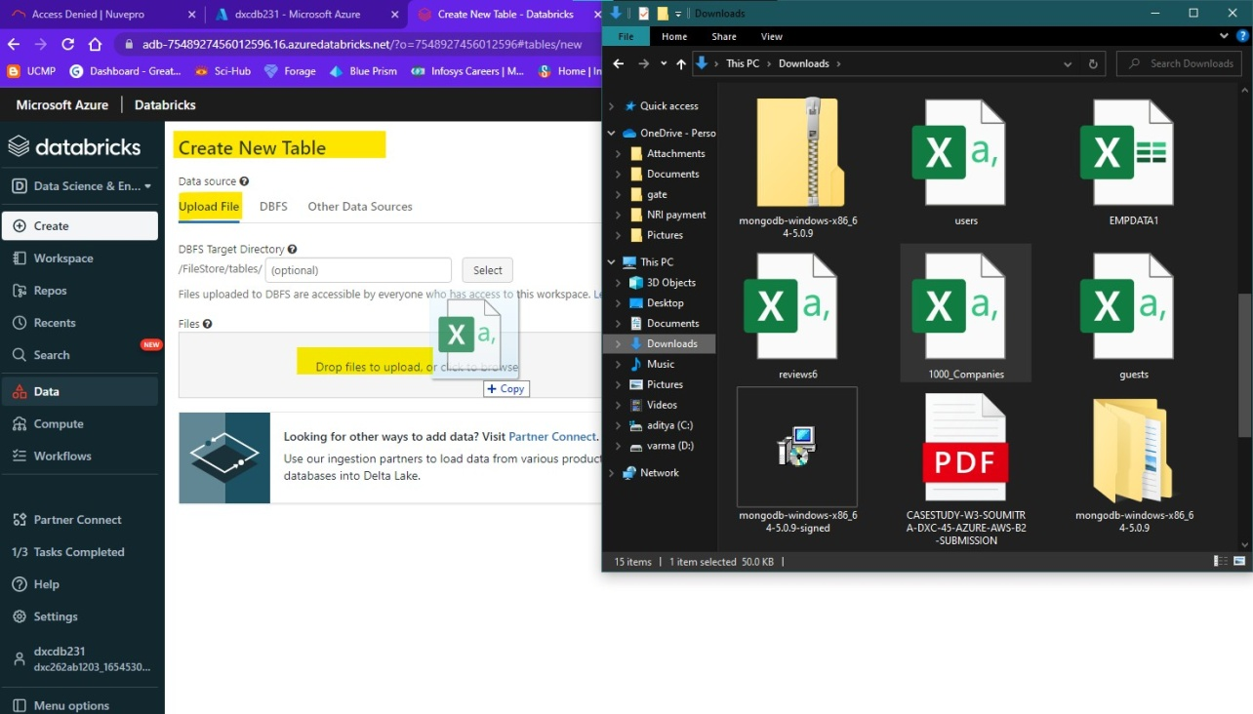

Step-3: after uploading the table click on create table in note book

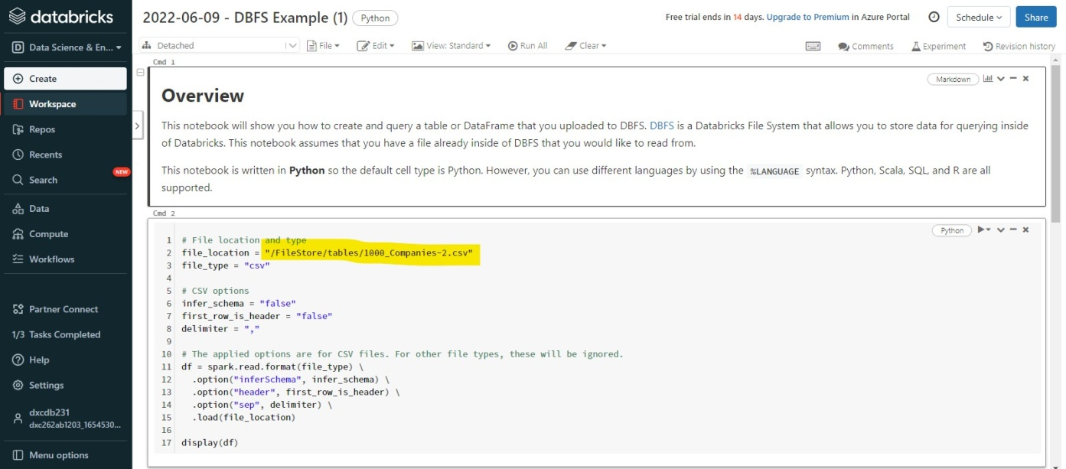

Step-4: after running the run all command. note that cluster is attached

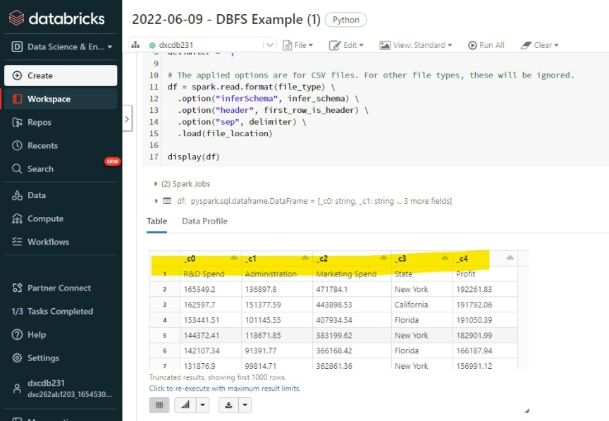

1. Explain the steps with screenshots how to create cluster in databricks?

Ans) To create a cluster in data bricks we have to follow the steps mentioned below

Step-1: login into the azure portal and navigate to the data bricks which we already created before

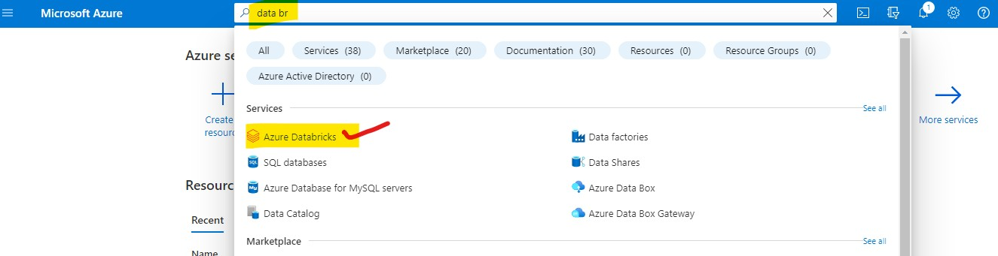

Step-2: after navigating to the data bricks portal and click on compute and click on create cluster

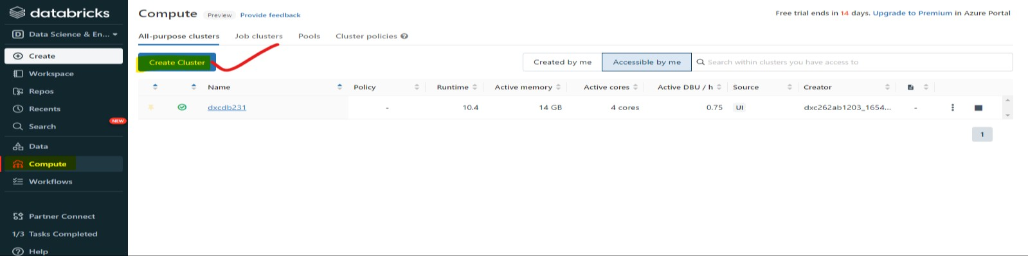

Step-4: after that name the cluster and select requirements and click on create-to-create cluster.

